**How To Use Bearish Seasonal Tendencies In HTF Analysis**

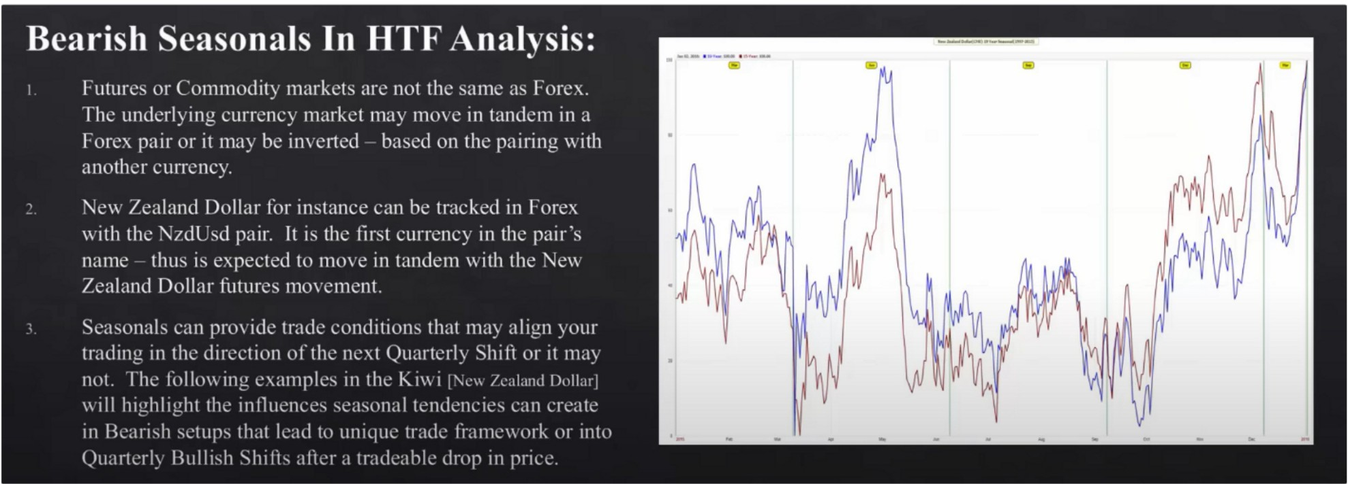

Use seasonal tendencies as a roadmap,

When the blue line and red line move in tendum direction, thats high probability seasonal tendency, when its choppy and back and forth its lower probability

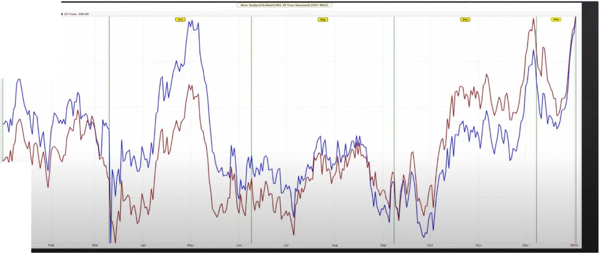

-

CE>

* ,..,,

For the kiwi, you want to be focusing on the june and december contract because thats where the moves happen if we look at the seasonal chart

Is there something technical in price that supports the seasonal tendency idea? This can lead us to the next quarterly shift

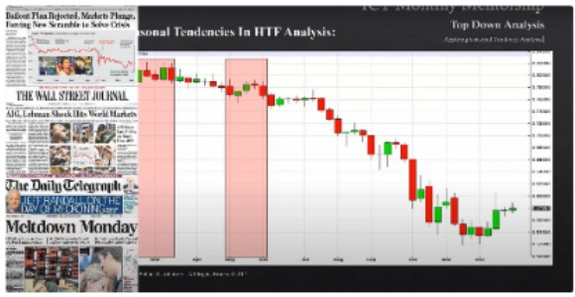

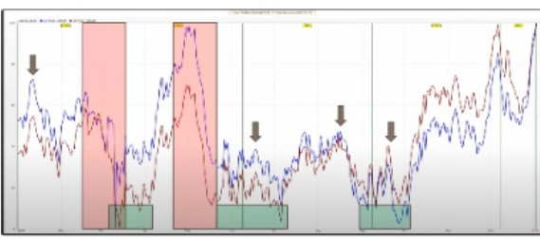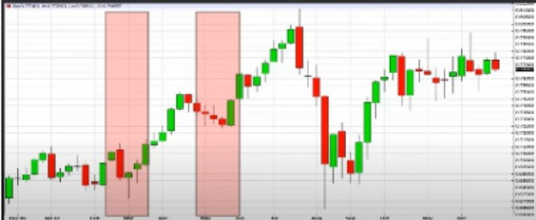

This is the macro few of the kiwi Combine it with technicals

Were not basing everything on the season tendency but were looking for clues, we will look at the confluences and see if the buys or sells are better

Theres going to be big macro events that will sometimes take control like the 2008 crash

If we have a seasonal tendency that suggests bullish prices, when the market is pre disposed to go

higher because its a bullish market, and were at a time of the day where the market should be bullish and its also at a time that interest rates are supporting that bullish idea, its also supported in the dollar index. When all these things come together thats when youre going to see high probability and you will do very very well if you stick to this

By the time youre done with this mentorship, you can go to any asset class and youll know right away if theres an opportunity or not.

# If

**Tendencies shown in these presentations, you**

**you are interested in the Seasonal**

**can find them at** [**www.MRCl.com**](http://www.MRCl.com/)

**Steve Moore is the best resource when it comes to Seasonal Tendencies in the markets.**

**I do not receive compensation for this statement. I use them personally.**

Arjo I Twitter, lnstagram I Linktree

Linktree. Make your link do more.

I https://t.co/HhmmTN1fUI

JavaScript is not available.

**'If#** https://twitter.com/arjoio